**Practical 3**

***Aim* :-** Use the commands ipconfig, ping, netstat and  
traceroute (tracert) to analyze their outputs.

**A : ipconfig**

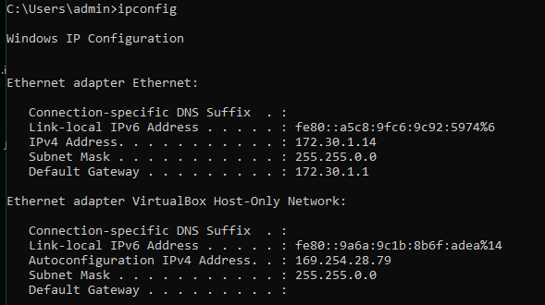

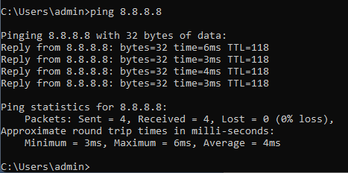**B: ping 8.8.8.8**

**C: netstat 8.8.8.8**

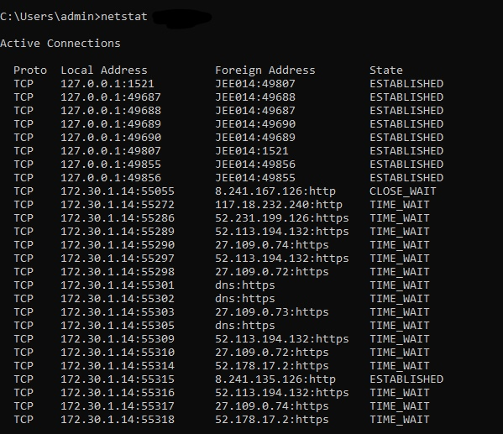

**D: tracert 8.8.8.8**